1.Write a Python program to extract all URLs (web links) from a block of text using  
regular expressions. Use the Cursor AI tool with zero-shot prompting to generate the solution

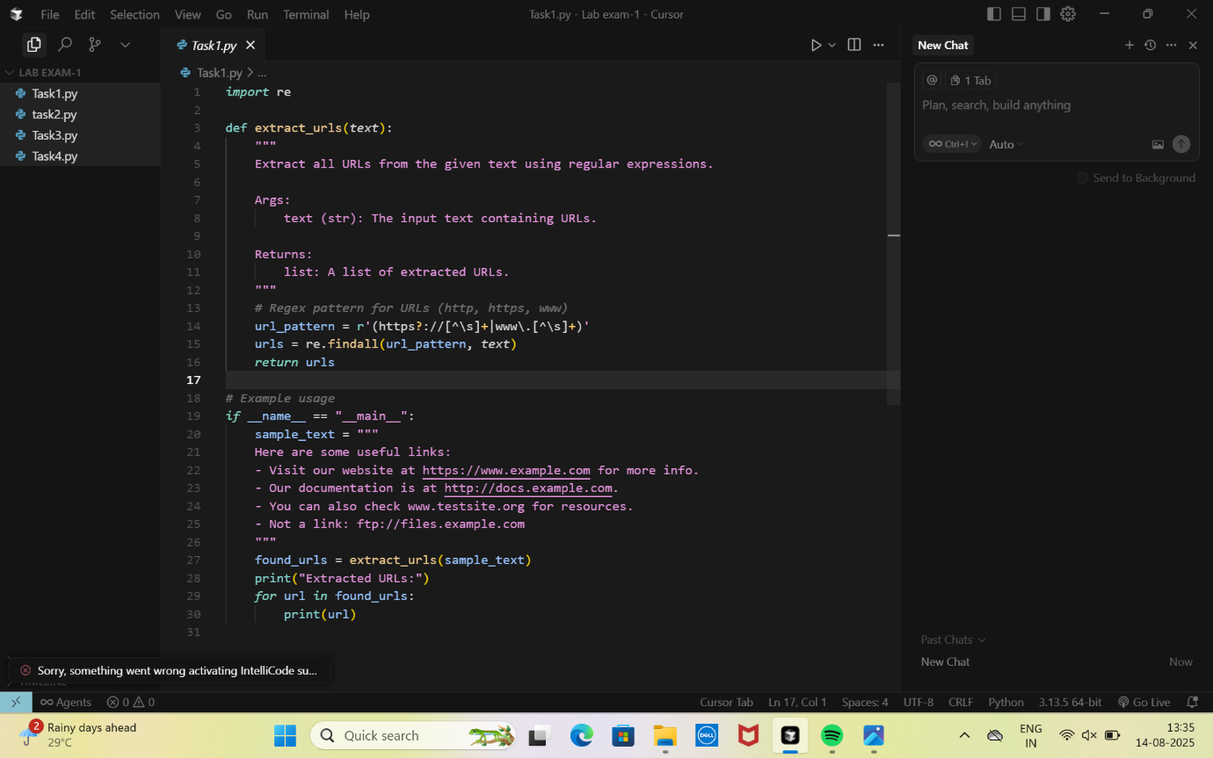

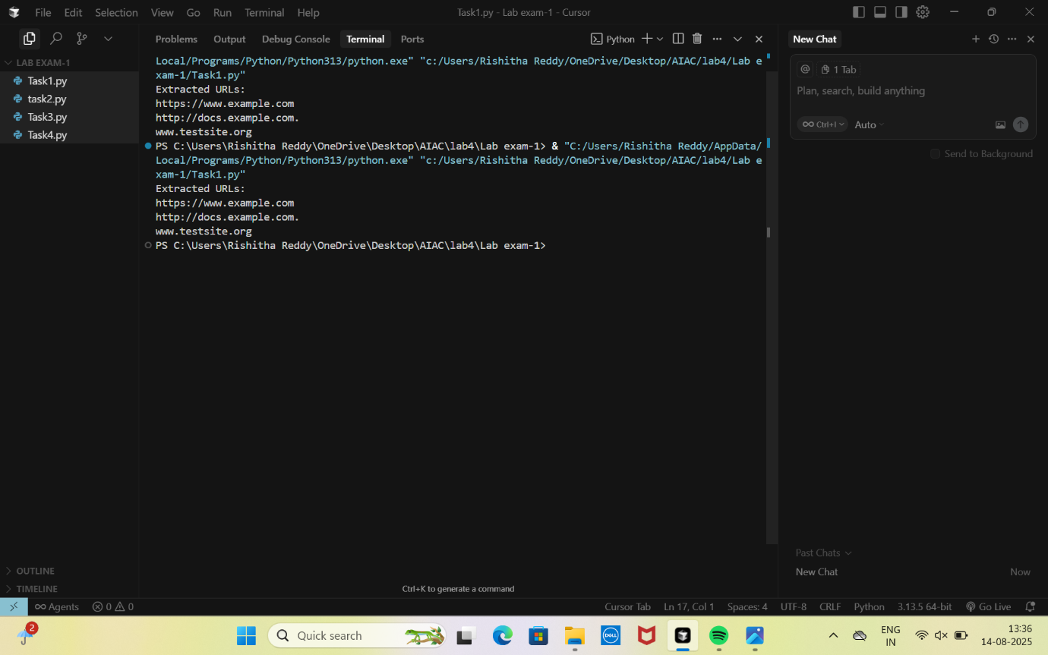

2.Given a list of books with their genres, write a Python function that recommends  
books based on a user’s preferred genre. Use the Cursor AI tool. Use few shot prompting

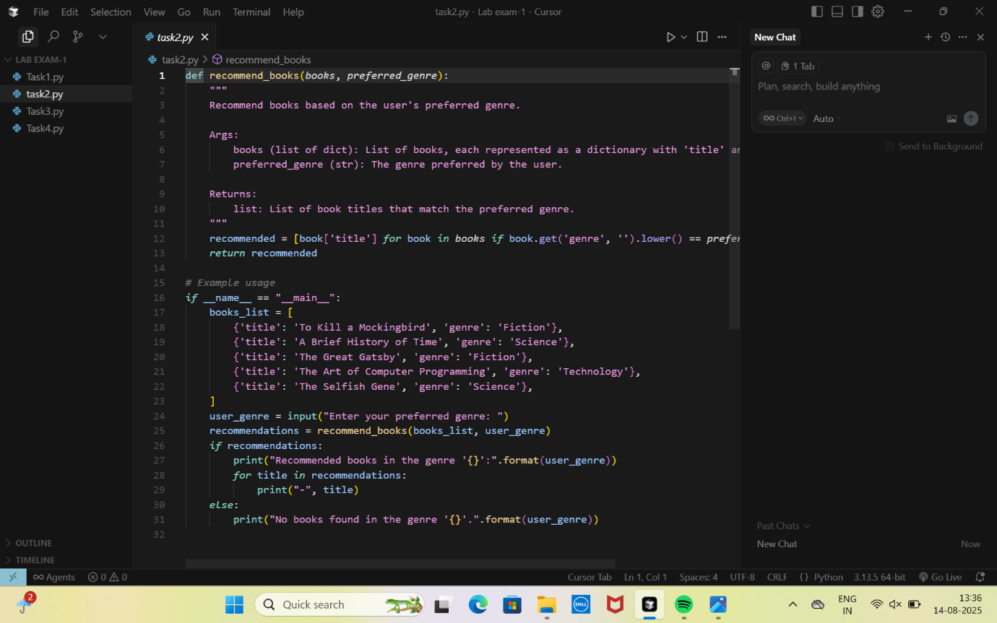

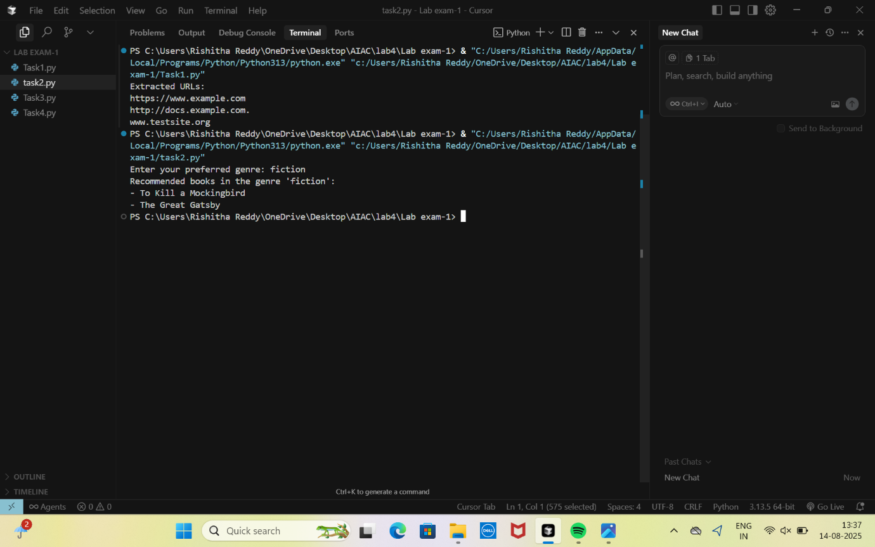

3.Write a Python program that generates all prime numbers between start and end  
(both inclusive) entered by the user. Use GitHub Copilot along with VS Code. Use few shot  
prompting

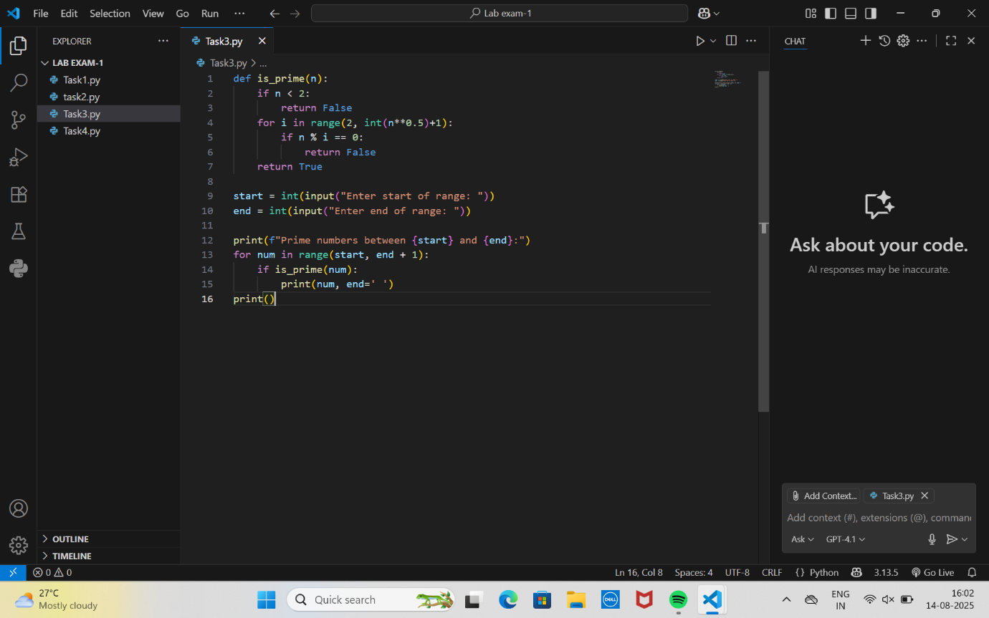

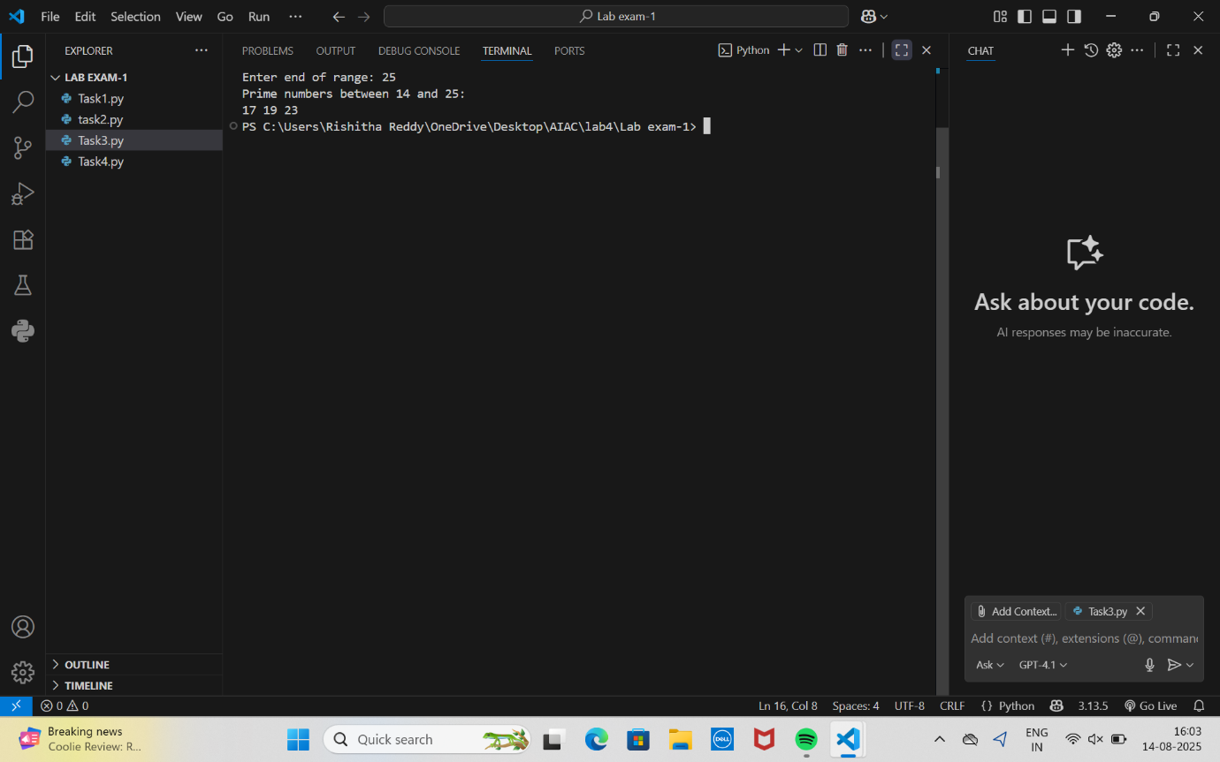

4.Write Python code that takes a list of student names and generates institutional  
email IDs in the format: <firstletter><lastname>@sru.edu.in Example: "Anita Sharma"→  
[asharma@sru.edu.in](mailto:asharma@sru.edu.in).

